Technical Design Blueprint: Cloud-Native Telemetry & WFM Data Platform

Olivera Sazos, Apr 2026

TECHNICAL DESIGN & ENGINEERING OVERVIEW DRAFT

This technical document details a cloud-native data platform designed to consolidate contact centre telemetry into a unified analytics layer. By integrating telephony metrics, workforce management (WFM) schedules, and organisational hierarchies, the solution synchronises performance data with operational structures to enable multi-dimensional trend analysis.

Design Approach

The platform utilises a Medallion Architecture to manage the data lifecycle. Raw ingestion ensures full auditability and replicability, while subsequent transformation layers enforce schema validation and data quality. The final refined layer provides high-performance, datasets optimised for downstream BI consumption and strategic decision-making.

Landing Temporary Layer (only for the new files to assure only they are processed)
Permanent Layer
- Injection Layer: Raw files, timestamp so not to be overwritten if the same name
- Bronze Layer: Structured tables
- Silver Layer: Transformed
- Gold Layer: Business-ready reporting datasets
Data Sources
- API: Agent telephony performance (daily grain)
- CSV Files: Agent schedules (daily ingestion)
- Excel Files: Team hierarchy (periodic updates)
Processing Flow
- Data is extracted using Python-based ingestion processes
- Raw data is stored in the Ingestion layer (original format) and in Bronze layer (after injection)
- Data is cleaned and standardised in the Silver layer in Landing Area
- Business logic is applied in the Gold layer
- Analytics consume Gold-layer datasets

- API INGESTION FRAMEWORK DESIGN
The agent performance API delivers daily summaries at the grain of (date, agent_id). The design must handle authentication token expiry, pagination, historical corrections, and idempotent reprocessing.

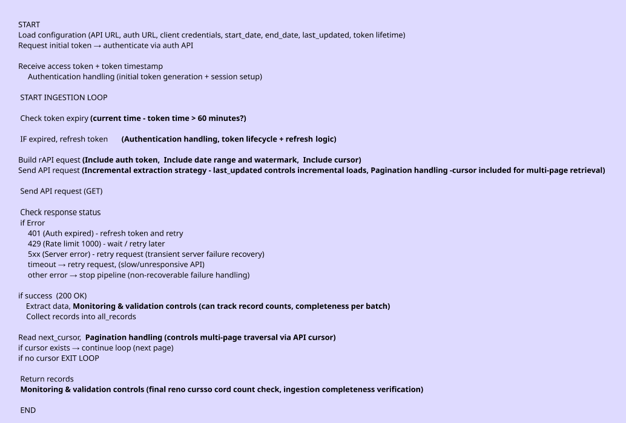
Error handling and retry strategy
- Ensures the pipeline is resilient when calling external APIs by handling failures in a controlled way.
- It distinguishes between permanent errors (which stop the pipeline) and temporary issues (which trigger retries).
- The strategy improves reliability by retrying transient failures, handling token expiry, respecting rate limits, and preventing the system from hanging or failing unnecessarily.

Reprocessing
- The script calls the same API every time it runs
- Reprocessing is enabled by the request parameters, especially the date range (start_date / end_date) and last_updated

- SCHEDULES ENGINEERING
CSV to be loaded daily. The load process to depend on storage architecture of files.
Overlaps to be handled in Silver layer; duplicates to be corrected to Gold layer, if required.
This is the simplest algorithm which could be enriched with slightly different logic, using different requirements (e.g. priorities)
The Overlap Resolution Algorithm Draft – Basic
Group data by employee and date so each person’s daily records are processed separately.
Within each group, sort records by start time so they are in chronological order.
Go through each record one by one.
For the first record, simply add it to the cleaned list.
For each next record, compare it with the previous one that was kept:
- If the previous record ends after the current record starts, there is an overlap.
- In that case, shorten the previous record so it ends at the current record’s start time.
Then add the current record to the cleaned list.
Repeat this process until all records in the group are processed.
Assumptions
- Earlier record is adjusted, when two records overlap, the earlier record is shortened so it ends at the next record’s start time. It is not replaced or removed.
- No overlapping records allowed, each employee can only have one active record at any point in time per day; overlaps are resolved by trimming.
- No explicit tie-breaker logic, If two records have the same start time, the order of processing determines the outcome. Both records are kept, but the earlier one may be reduced to zero or near-zero duration depending on overlap handling.

- ARCHITECTURAL DESIGN
The architecture follows a medallion lakehouse pattern (Bronze → Silver → Gold)
  - High Level Architecture Draft
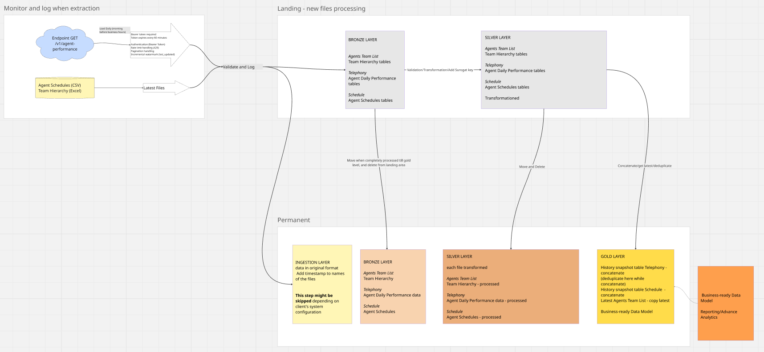
  - Key Design Decisions
Data Architecture (Medallion Framework)
- Use Landing area for new files and their processing.
- Move files from Landing to Permanent storage only after the full pipeline reaches Gold level.
- Immutable Storage, maintain an unchangeable Bronze layer to ensure logic can be replayed at any time.
- Hierarchy-first processing, process Team Hierarchy first to create Surrogate Keys required by other datasets.
- Original data preservation, store all source files in original formats in ingestion layer for auditability and easy reprocessing.
- Staged ingestion, if possible, use a file-to-table approach from the Ingestion layer to the Bronze tables.
  - Validation & Logging
- Processing checks, verify dates, IDs, and name clarity in Silver layer.
- Halt or alert if invalid records (nulls/duplicates) exceed a 5–10% threshold.
- Identity resolution, match Telephony data (no employee_id present in data) to IDs via standardised (uppercase) name lookups.
- Historical tracking: use Surrogate Keys (ID + Date) to link calls to the correct manager at that point in time
  - Monitoring
- Execution Logs: The system tracks processing time and error flags for every run.
  - Gold Layer & Reporting, Historical Snapshots
- Telephony and Schedule data are concatenated into History Snapshot Tables in the Gold Layer to support trend analysis.
- Business-Ready model, dimensions and fact tables to connect to dim tables are conformed via Surrogate Keys and date to provide Star Schema for Reporting and Advanced Analytics.
  - Assumptions
- Availability, source systems (API, CSV, Excel) will be available and accessible daily within the agreed processing window.
- Unique Identifiers, Agent_id is consistent and unique across all three data sources (Telephony, Schedules, and Team List).
- Infrastructure, the cloud environment has the permissions and capacity to host production-grade ETL/ELT pipelines.
- API Reliability, mock API behavior (rate limits, pagination, and historical corrections) accurately reflects production env.
- Team List Frequency, while only the latest file applies, it is assumed a new file is provided when a hierarchy change occurs.
- Connectivity, bearer tokens for the API can be refreshed programmatically without manual intervention every 60 minutes.

  - Risk Register
Risk ID | Risk Description | Impact | Mitigation Strategy
R01 | API Rate Limiting, ingestion fails or stalls due to HTTP 429 errors during large historical re-loads. | Low | Add delays between retries that increase each time.
R02 | Schema Evolution, new fields added to the API or Excel files break existing transformation pipelines. | Medium | To be resolved in Silver layer
R03 | Manual File Errors: CSV or Excel files contain corrupt formatting, missing headers, or invalid date types. | High | To be resolved in Bronze or Silver layer. Reject file or quarantine, create error flags in Silver Layer
R04 | Incomplete API Payload, API returns partial responses, leading to missing agent records for specific dates. | Medium | Validate record counts against expected thresholds. Ideally to be solved with flags in Silver layer

- DIMENSIONAL MODEL DIAGRAM
The dimensional model uses a star schema to support reporting by date, agent, team, manager, and financial year. Slowly Changing Dimensions are implemented for the agent-team hierarchy, since agents change managers and regions over time.
The star schema centres on two fact tables; each connected to shared dimension tables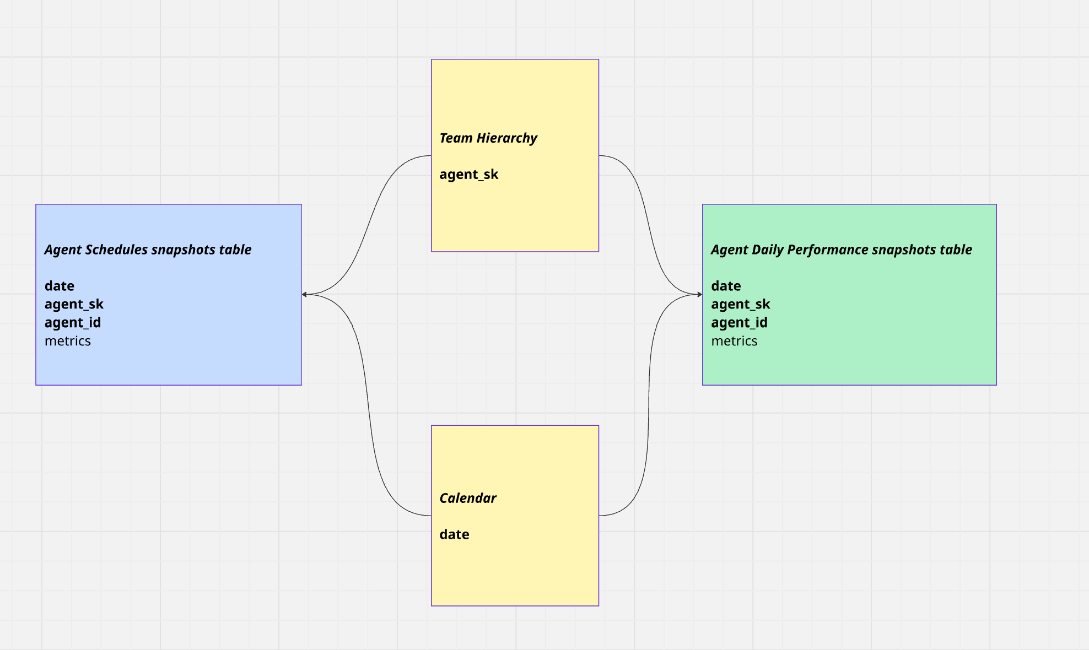

Key Design Decisions & Justifications
Design Choices
- Star Schema, fact tables (Schedules/Performance) connect to shared dimensions (Hierarchy/Calendar) for reporting.
- The Team Hierarchy tracks manager changes over time using unique Surrogate Keys.
- Daily Snapshots, performance and schedules are recorded daily to preserve "as-was" historical data.
- Surrogate Key Grain: all tables link via agent_sk to keep history stable.
- History is changed only (to be clarified) if duplicate records come in Telephony table (agent id and date grain).
Why This Works
- Historical Accuracy, you can see who an agent's manager was on a specific day in the past, not just who it is today.
- Performance: BI tools process this structure much faster.
- Planned vs. Actual, the shared Calendar and SK allow to compare an agent's scheduled hours against actual performance.
Reporting
- Trend Analysis: Daily snapshots make it simple to track performance growth over time.
- Consistent Reporting: Centralized dimensions ensure everyone sees the same team structures and date totals.
Generate Surrogate Key
(Agents Team List: to create a surrogate key (sk_employee) in a slow-moving table, assign a unique, sequential number to every row. The simple counter way’)

SUMMARY DRAFT

This document presents the design of a cloud-based data platform that consolidates contact centre operational data into a unified reporting and analytics solution. The platform integrates multiple data sources to deliver a consistent, reliable, and comprehensive view of agent performance, workforce activity, and organisational structure.

The solution brings together three core datasets: agent telephony performance, scheduling information, and team and manager hierarchy data. By combining these sources, the platform enables alignment between operational performance, workforce planning, and organisational structures over time.

The objective is to deliver a scalable and maintainable analytics platform that supports accurate daily reporting while preserving historical data for trend analysis and performance insights. The design ensures data consistency, traceability, and usability for business stakeholders.

Overall, the platform establishes a trusted data foundation that enables managers and team leaders to monitor performance, improve operational efficiency, and make informed, data-driven decisions.
Proposed Architecture Overview

The architecture follows layered (medallion) approach to ensure scalability, data quality, and traceability. Data is ingested from all sources into a central platform and stored in its raw form to support auditability and reprocessing if required. It is then transformed and enriched through structured processing steps, resulting in refined datasets optimised for reporting and analytics.

This design enables reliable insights, supports incremental data processing, and provides a strong foundation for both operational and strategic decision-making.
Key Risks
- Data may sometimes arrive incomplete or with delays, so not all information is available at the expected time
- Previously recorded historical information may be updated or corrected later, which can affect past reports
- Source files may contain duplicate entries or inconsistent identifiers
- Information coming from different systems may not always match or align correctly when combined
Trade-offs
- Simple vs reliable, making a system safer and more reliable (adding checks and backups) makes the setup much more complicated
- Fast vs cheap, getting data updates instantly makes the system faster but costs much more money to run
- Flexible vs controlled, allowing system to easily change its structure makes it adaptable, but requires strict rules to stop it from breaking
Recommended Refresh Frequency
A daily refresh is recommended as the baseline:
- Aligns with business reporting needs
- Minimises cost and operational complexity
- Supports stable and reliable data processing
- Plan for future scalability (real-time or near real-time if required)

